**EXERCISE: 02**

**DATE: 20.11.2020**

**AIM:**

To give a list and a number X count the number of occurrence of x in the given list

**PROGRAM:**

def countX(lst1,x1):

count=0

for i in range(0,len(lst1)):

count=count+1

return count

lst=[]

n=int(input())

for i in range(0,n):

inp=int(input())

lst.append(inp)

print(lst)

x=int(input())

y=countX(lst,x)

print(y)

**LINK:**

[**http://103.53.53.18/mod/vpl/forms/submissionview.php?id=230&userid=1697**](http://103.53.53.18/mod/vpl/forms/submissionview.php?id=230&userid=1697)

**OUTPUT:**

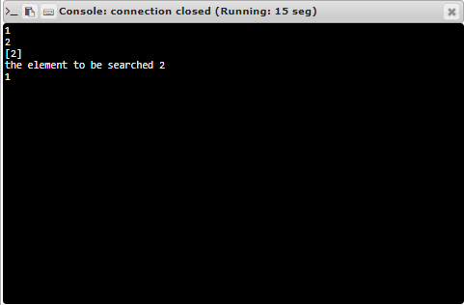

**RESULT:**

Thus the program is executed successfully